Behavior Plan

At the beginning of the school year, each family received a form that laid out the behaviors expected of your child. When students need reminders to make good choices in the classroom, they will be asked to move their name card from green to yellow to red to black. When students are making good choices on they can earn their way back to green. Students will be rewarded for good behavior and students making poor choices will have to fill out a “Thinking Sheet”, and have a negative consequence. When your child gets home, ask them about the color on their class behavior card.

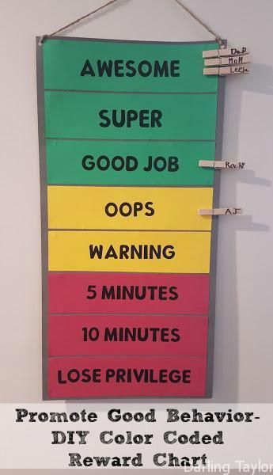

Source:

Picture

https://www.pinterest.com/explore/home-behavior-charts/